The History of Chinook Helicopters
Student’s Name
University Department
Course Name/Number
Professor’s Name
Date

The History of Chinook Helicopters
Introduction
The history of aircraft has been documented many times by different people. Yet, few studies have been published on specific aircrafts such as Chinook helicopters. This essay attempts to compile inputs from different secondary materials, including peer-reviewed article journals, to provide compelling information on the history of Chinook helicopters. The aim of this report is to answer the question, how did the CH-47 came to be such an exemplary aircraft for the army? Based on the data collected from different primary and secondary materials, I argue that apart from its military reputation across the world, Chinook helicopters are uniquely distinguished from the other helicopters as a premier workhorse that has been able to move combat troops and heavy cargo for the army of the United States and many other countries in the last 50 years.
Early Development
The technique used in the development of Chinook helicopters can be traced back to the early 400BC with the invention of rotary-wing concepts. According to Valkenburgh (2012), rotary-wing concepts came from the Chinese writings that described wooden toys. The first scientists to experience it include Leonardo Davinci, who tested the concept in his Helical Air Screw in the 15th century (Valkenburgh, 2012). Various helicopter designs were invented during the early years before the emergence of Chinook helicopters. Such helicopters that came before the Chinook include the dual rotor design of 1941, single rotor design like R-5 and R-6 of 1943, and Vs-300 and R-4 of 1939 (Valkenburgh, 2012).
Findings
The Tandem Design
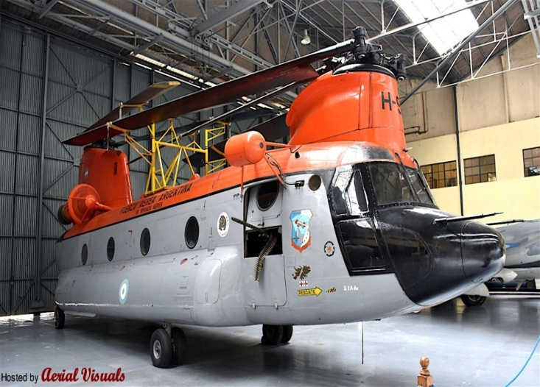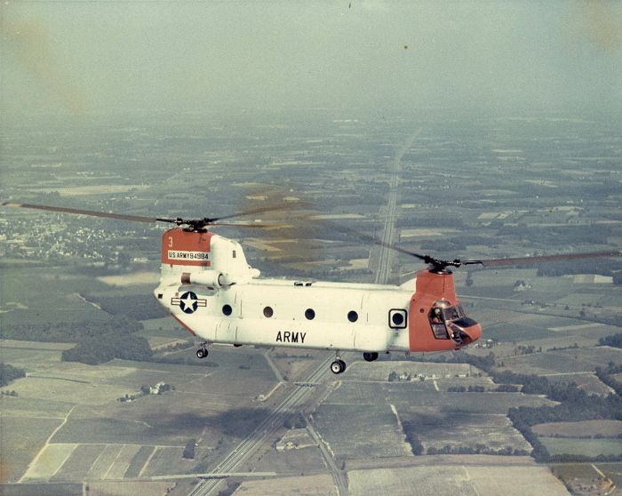
Tandem Design Figure 1 (Source: Aerial Visuals) Tandem Design Figure 2 (Source: Chinookhelicopters.com
Chinook helicopter (CH-47) is a twin-engine (figure 1 and 2 shown above), tandem rotor helicopter that is designed to transport cargo, army troops, and weapons to facilitate army operations (FAS, 1999). Unlike any other ever built-in aircraft manufacture history, this aircraft is due to its sophistication and efficiency to be used during the day, at night, visual, and instrumental conditions (FAS, 1999). With a maximum airspeed of about 170 knots, CH-47 has remained the best cargo and troop ferry plane for the U.S. Army and other countries around the world. However, how did the CH-47 came to be such an exemplary aircraft for the army? The answer to this question lies within the historical development of this plane.
CH-47 Development
The demand for more advanced and capable aircraft in the 1960s created the invention of the famous Chinook helicopters that have been widely embraced for its unlimited capabilities. The Chinook helicopter (CH-47) was originally designed in the late 1950s by Vertol Aircraft Company. Vertol was initially known as Piasecki Helicopters, which designed most of the military aircraft before the 1940s. The company that was owned by Frank Piasecki later changed to Vertol Aircraft Company in the late 1950s and was later acquired by Boeing in 1960 (SOFREP, 2015). This is the beginning of Chinook helicopters.
Before developing the CH-47 helicopter, other versions were tried to meet the specific needs of the army troops and operations. As Grina (1975) explains, the Chinook helicopter was introduced to the U.S. army in 1962 after a dynamic engineering development. Early versions of the Chinook helicopters that created and paved the way for its emergence include the YHC-1A manufactured in 1958. This helicopter had significant power and was capable of carrying about 20 troops. Even though the army liked it, they also felt that it was too big for combat and too small for cargo. As such, the army went for a heavier aircraft that would meet their demands and needs.
In 1962, the first version of the CH-47 was created and given to the army for trials. CH-47A was created in 1962 and used in Vietnam. This was a tandem-rotor medium transport helicopter designed to ferry the army troops and transport ammunition, supplies, and artillery for the army (FAS, 1999). The early versions of CH-47 were allowed to operate within the 11th air assault division in the early years of its design. But, in 1965, the army redesigned the aircraft to the first cavalry division.
The changing operations and environment informed the chinook helicopter's development and evolution. The roles and functions of aircraft were becoming immense, which consequently influenced the need for more advanced designs to meet these changes. As Rhoads (2006) further asserts, the development of the Chinook helicopter came as a result of the demand for changes. Airframe durability and damage tolerance were among the primary structural design criteria for military aircraft in the early years. However, several changes emerged, including the need for a more powerful and large aircraft to survive different conditions. According to Rhoads (2006), different analytical tools and methods were developed to determine the external and internal loads for such aircraft's spectrum development. The development of the first version of Chinook, CH-47 helicopter in 1962, was a clear indication that the army would get what they wanted. However, this version was also faced with challenges, which resulted in a change to other versions. For example, the CH-47A version was limited in the payload by its rotor blade designs (SOFREP, 2015).
The second version, CH-47B, was introduced in 1967 to reduce the limitations of the first version. According to FAS (1999), this second version of the Chinook helicopter used the Lycoming T55-L7C engine, which improved its airframe. With an improved airframe, the CH-47B had better stability than its predecessor. However, the company produced about 108 B model units before they shifted to another version, CH-47C. As Storey (2011) further explains, the Chinook helicopters have had an interesting history with different countries where it has been used as army aircraft. Many countries, including Canada, have procured Chinook helicopters due to their unique and suitability qualities that make them outstanding than the rest of the army aircraft.
The CH-47C was an improvement from the previous version as it had a large capacity for cargo transport than the previous. For example, it could carry about 20,000 pounds of cargo that the previous versions could not. This aircraft was designed specifically to meet the army's requirement of an aircraft that could carry about 15,000 pounds worth of cargo across a 30-mile radius (FAS, 1999). The development of the Chinook helicopter continued with another model, CH-47D. FAS report shows that this model was the answer to the military needs as it was able to carry a large number of military personnel, supplies, and equipment over a vast distance. Its cargo capacity and speed provided the army personnel with the capability unequaled by any other aircraft in the world (FAS, 1999). Unlike the previous models, this mode could lift up to 131,000 gallons of fuel and ferry more than 5,000 soldiers over a long distance (FAS, 1999). However, even though the CH-47D model is not the last version of the Chinook helicopter to be manufactured, it has remained the models' significant aircraft. The other versions that came, such as improved cargo helicopter (ICH), CH-47 F, comprised of few changes in the CH-47D model.
Conclusion
The Chinook helicopter has had a significant and fascinating history since its first version CH-47A, was manufactured by Boeing in 1962. Changes in the military operations and environment influenced the different Chinook helicopter designs and models that came later. Despite that it is just part of the military's aircraft collections, Chinook helicopters have remained a uniquely distinguishable workhorse that ferries army troops and cargo and can withstand changing conditions more than any other military aircraft in the world.

References
FAS. (1999 November, 19). “CH-47 Chinook.” https://fas.org/man/dod-101/sys/ac/h-47.htm
Grina, K. I. (1975). Helicopter Development at Boeing Vertol Company. The Aeronautical Journal, 79(777), 401-416.
Pictures of Chinook Helicopter: 59-04984. Chinookhelicopter.com. Retrieved from http://www.chinook-helicopter.com/history/aircraft/A_Models/59-04984/59-04984.html
Rhoads, D. (2006, March). Rotorcraft airframe load spectrum development. In 9th Joint FAA/DoD/NASA Aging Aircraft Conference, Atlanta.
S/n H-19 FAA. Ariel Visuals. Retrieved from http://aerialvisuals.ca/AirframeDossier.php?Serial=38618
SOFREP. (2015 September, 21). “Milestone Monday: The Ch-47 Chinook at 54.” SOFREP. Retrieved from https://sofrep.com/fightersweep/milestone-monday-ch-47-chinook-54/
Storey, E. (2011). CH-147D Chinook Nose Art in Afghanistan. Canadian Military History, 20(1), 7.
Valkenburgh, V. N. (2012 November, 11). Chinook-The legacy of Tandem Rotor Helicopters.” U.S. Tandem Rotor Helicopter Evolution. Retrieved from http://www.chinook-helicopter.com/history/Nick_Van_Valkenburgh/H-47_Chinook_Legacy_Nov_2012.pdf

